Jira progress 30-12-2025
Jira Automation = rules that do work for you inside Jira.
No coding, just IF this happens → THEN do that.
What is Jira Automation?
Jira Automation lets you automatically:
- Update issues
- Change status
- Send notifications
- Assign users
- Create / link issues
- Enforce workflows
All based on triggers, conditions, and actions.
Where you find Automation
- Project-level:
Project settings → Automation
(Rules apply only to that project)
- Global-level (Admin):
Jira settings → System → Automation rules
(Applies across projects)

Core Components (Very Important)
Every rule has 3 parts:
Trigger – WHEN
What starts the rule
Examples:
- Issue created
- Status changed
- Field updated
- Scheduled (time-based)
- Sprint started / completed

Condition – IF
Rules that must be true
Examples:
- Issue type = Bug
- Priority = High
- Assignee is empty
- Reporter = User
Conditions are optional, but powerful.

Action – THEN
What Jira does
Examples:
- Assign issue
- Transition issue
- Add comment
- Send email / Slack message
- Create another issue
Types of Conditions
- Issue fields condition
- JQL condition
- User condition
- Compare two values
- Related issues condition (Epic / Parent / Subtasks)

Smart Values (Advanced but Important)
Smart values let you access Jira data dynamically.
Examples:
- {{issue.key}}
- {{issue.summary}}
- {{assignee.displayName}}
- {{now}}
Used in:
- Comments
- Emails
- Field updates
Automation Rule Limits
- Depends on Jira plan (Free / Standard / Premium)
- Each action = rule execution
- Global rules consume more quota
Jira Automation works
WHEN (Trigger) → REQUIRED
IF (Condition) → OPTIONAL
THEN (Action) → REQUIRED
ONLY Global Administrator
- System Admin / Jira Admin (Global level)
- Has access to Global Automation
- Can import rules into:
  - Global scope
  - Any project (if permitted)

“only a Global Jira Administrator can import automation rules”
What is a Branch in Jira Automation?
A Branch rule / related issues lets you run actions or conditions on other issues related to the trigger issue, not just the issue that triggered the rule.
Branch vs Condition
Feature | Branch | Condition
Purpose | Change issue context | Filter issues
Acts on | Related issues | Current issue
Can update issues | Yes | No

Automation rule for the close the epic if all issues are done

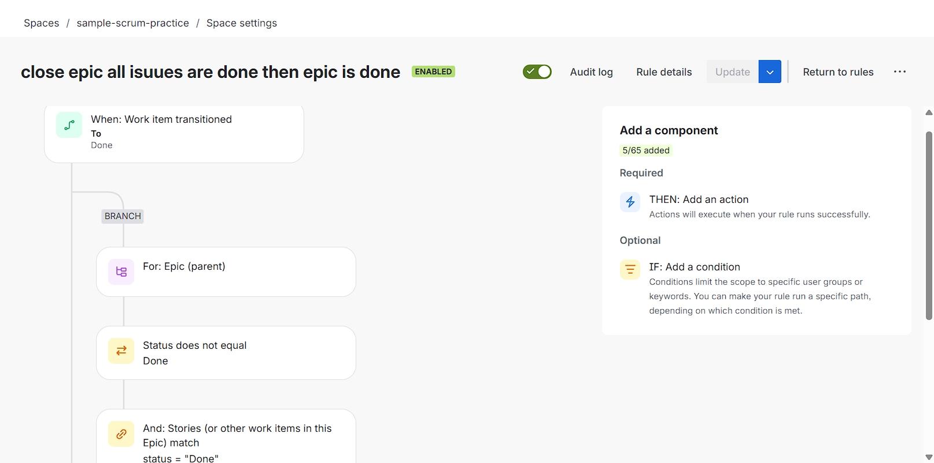
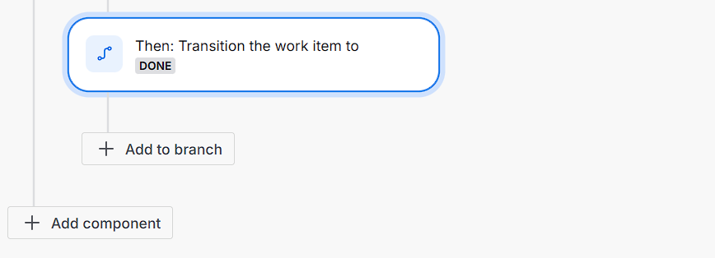

Sample image of epic where initially the epic in progress before the the last issues are done

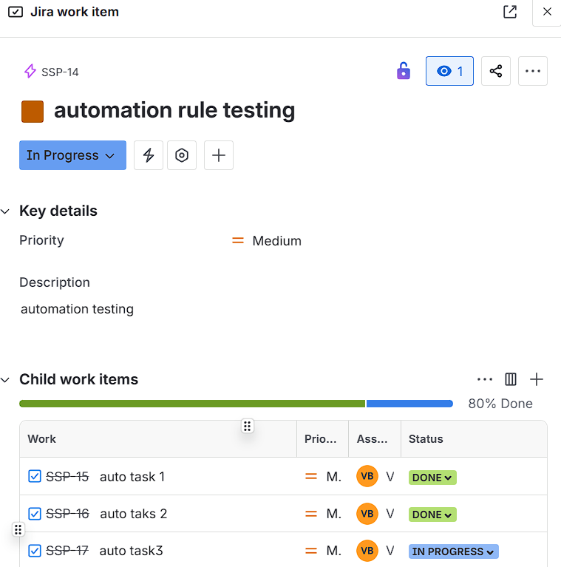

Sample image of epic when the last work item is done then automation rule apply then epic is done
